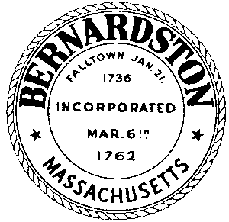
TOWN OF BERNARDSTON
Office of the Town Clerk
____________________________________________________________________________________
P.O. Box 504, 38 Church St., Bernardston, MA 01337 Email: townclerk@townofbernardston.org
Christina Slocum-Wysk, Town Clerk Phone: 413-648-5408

Official Town Election Results

There are 1,793 registered voters and only 49 voted.

Position | Name | Votes
Assessor One Year | William Bradley Deane | 48
Assessor Two Year | Melissa A. Murphy | 45
Assessor Three Year | Russell L. Deane | 45
Board of Health Three Year | Barbara Ann Killeen | 45
Constable Three Years | Peter A. Shedd | 47
Cushman Library Trustee One Year | Zoe E. Darrow | 44
Cushman Library Trustee Three Year | Jeana Bachinski | 43
Cushman Library Trustee Three Year | Elizabeth Marie Demarco | 44
Cushman Library Trustee Three Year | Joel W. Finnell | 44
Cushman Library Trustee Three Year | Karen L. Fitzpatrick | 43
Powers Institute Trustee Two Year | Kristina Dawn Streeter | 42
Powers Institute Trustee Three Year | Kenneth Richard Bordewieck | 45
Powers Institute Trustee Three Year | Paula Ann Reid | 45
Powers Institute Trustee Three Year | Brandon Gerald Staiger | 46
Powers Institute Trustee Three Year | Shannon Wissman-Hoar | 44
Recreation Commission Two Year | Jennifer Lynn Stafford | 48
Recreation Commission Three Year | Clayton Cardin | 47
Recreation Commission Three Year | Jenna Skutnik-Sheffield | 46
Selectman Three years | Brian K. Hervieux | 49

