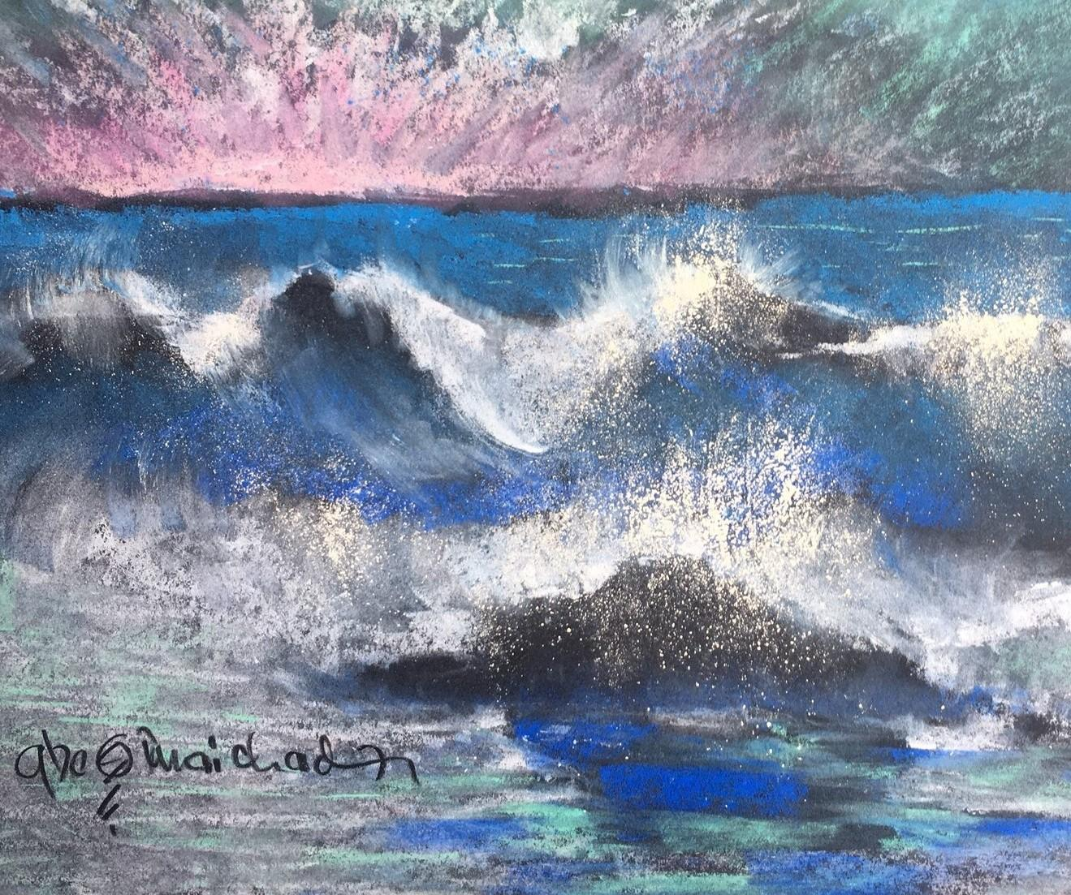

Pastel Paint Seascapes
A Hands-on Pastel Workshop
For Adults & older teens 18+ With Pastelist Greg Maichack
www.GregoryMaichack.com
This pastel painting workshop serves sheer beginners to advanced artists.
All materials provided, including professional grade pastels, paper and pencils.
Date/Time: Sunday April 14th at 11:30 am to 1:30 pm

Location:1739 Bernardston Unitarian Meetinghouse
49 Church St. ~ Bernardston MA

This program is supported in part by funds from the Bernardston Local Cultural Council a local agency supported by the Massachusetts Cultural Council, a state agency.

